**SUMS TO DO - 2 (TOPIC: STABILTY USING ROUTH CRITERION)**

1. The Ch. Eqn. of the system is given as



Investigate the range of values of gain, *K*, using Routh’s array for the system to be stable.

2. The feedback control system shown below, for which find the stability check using Routh array

Consider (i) without the factor K (ii) with the factor K, Investigate the range of values of gain, K, using Routh’s array for the system to be stable.

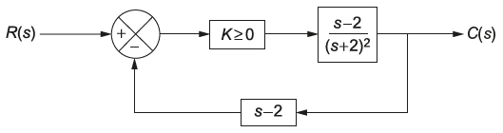

3. The OLTF of a UFB system is 

Find the number of roots that lie in the RH of the s-plane using Routh array.